**ENHANCED GOODS DELIVERY MANAGEMENT**

# **PROBLEM STATEMENT:**

In the era of booming e-commerce and online shopping, the conventional goods delivery systems face challenges in meeting the increasing demands for speed, reliability, and convenience. As exemplified by maintaining Hub, there is a growing need to develop a comprehensive solution that leverages the power of Internet of Things (IoT) technology to transform the goods delivery process into a more efficient, customer-centric, and streamlined operation. This entails addressing issues related to real-time tracking, secure storage, seamless coordination, and data-driven decision-making to enhance the overall delivery management process. Therefore, a robust IoT-based system needs to be conceptualized and designed to cater to these challenges, ultimately aiming to elevate customer satisfaction, optimize operational workflows, and foster innovation in the goods delivery industry.

# **solution:**

Creating a solution for enhanced goods delivery control much like a locked Hub the usage of the idea of the net of factors (IoT) entails integrating diverse technologies to optimize the delivery process and provide a unbroken enjoy for both clients and shipping personnel. Here's a comprehensive solution define:

1. **Hardware Infrastructure:**

Set up a network of smart delivery hubs equipped with IoT devices and sensors. These hubs can be strategically located in residential complexes, commercial areas, and public spaces.

* Smart Lockers:

Installation relaxed lockers with electronic locks and IoT-enabled manipulate panels. These lockers can be of diverse sizes to accommodate one of a kind kinds of programs.

* IoT Sensors:

Equip every locker with IoT sensors to reveal temperature, and protection status. This information can help ensure the safety and integrity of brought goods.

* Connectivity:

set up a reliable internet connection for real-time conversation between the crucial system and the IoT devices at each hub.

**2..Software Platform:**

Expand a robust software platform that connects all of the hardware components and provides a seamless person revel in.

* **Package Management:**

Enable users to select delivery hubs, locker sizes, and delivery times. Provide notifications when packages are ready for pickup or have been delivered.

* **Authentication:**

Implement secure authentication methods such as QR codes, PINs, or biometric scans to ensure only authorized users can access lockers.

* **Route Optimization:**

For delivery personnel, incorporate route optimization algorithms to ensure efficient package drop-offs across various hubs.

**3. IoT Integration and Automation:**

Make use of IoT abilities to streamline the whole transport process and enhance customer delight.

* **Package deal Detection:**

IoT sensors can stumble on while a bundle is located inner a locker, triggering notifications to the recipient it will denote that light will keep's on in the hub.

* **Remote Locker control:**:

Allow customers to remotely open lockers using the secured hub and mobile app otp verification, improving comfort and decreasing wait instances.

**4. Security and Privacy:**

Implement strong security measures to protect user data and prevent unauthorized access.

* **Access Logs:**

keep distinct get right of entry to logs, such as snap shots from cameras, to track any suspicious pastime.

**5. Customer support:**

Offer responsive customer service to deal with any problems or questions users would possibly have.

* **Chatbots and assist center**: enforce AI-powered chatbots and a help middle within the app to help customers in actual-time.

**Block Diagram**

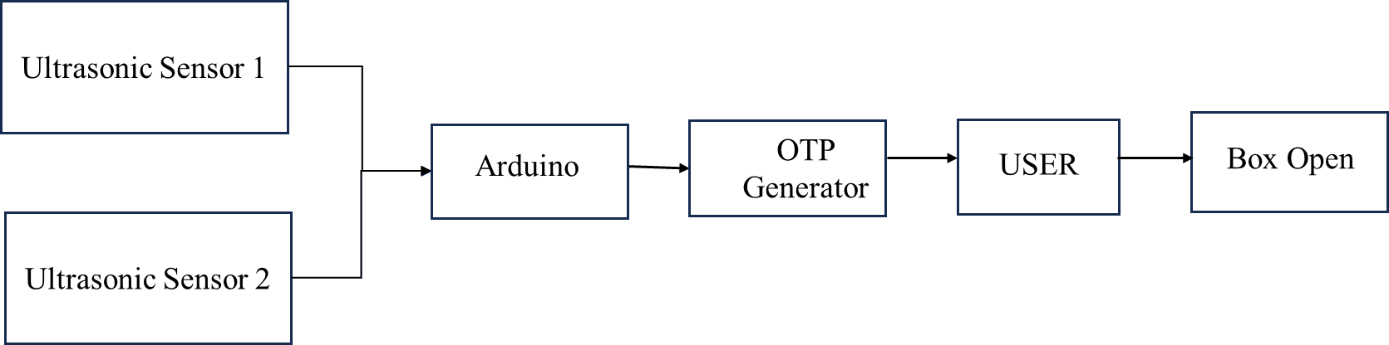

**Flow chart**

